Ravan Muradzada

Task 1
- Adding a disk to VM
To add a new disk to VM, we need to right click it in VMWare Workstation Pro and select Settings. There we add new hard disk. I prefer HDD.
Then we boot the system and run `lsblk` command to see disks:
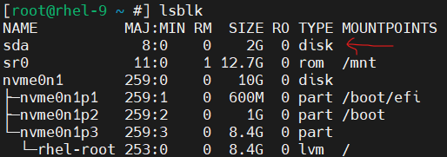

2.Stratis Packages
First, we need to download the stratis service and command line utilities:
`dnf install stratisd stratis-cli`.

Then we need to start and enable its service to launch at boot:
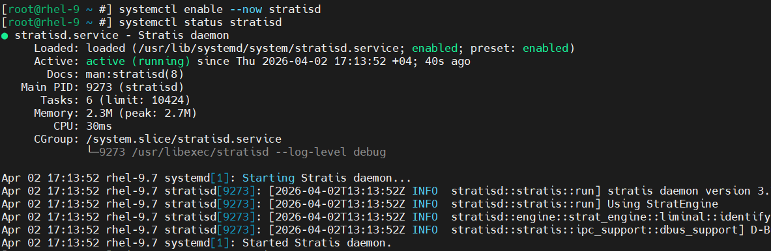

3.Creating Pool
We need to remove all block devices where we want to create stratis.

Then we create a pool named “idtechpool”:

Now we can verify the pool is created successfully:

4.Creating File systems
We create and check our new filesystems (idtech1 and idtech2):
The first filesystem is 600 MiB, the second is 700 MiB.

5.Adding a new disk
Now it is time to add a new disk to our pool. First, we need to add a new disk from the VMWare Workstation Pro. We need to right click VM and add hard disk here. I defined its capacity 3 GB.

Let’s see it using `lsblk`:
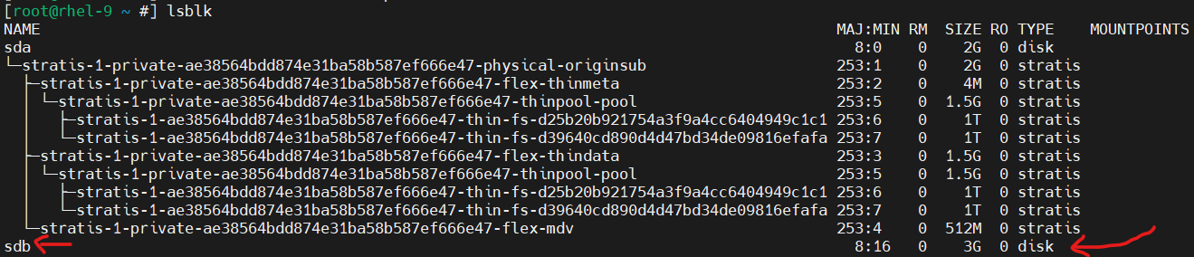
As you can see, its name is `sdb`.
We can use `wipefs –all /dev/sdb` to remove existing stuff in this disk, but that is not mandatory, because we newly inserted this disk (there is nothing on it yet)

We use this command to add a new disk to pool:
As you can see the size of the pool has increased.

6.Extending Pool
Stratis filesystems don't work like LVMs — we cannot resize them manually, Instead, Stratis uses thin provisioning, that means the filesystems can grow automatically from the pool as needed. The "size" we set at creation is just an initial allocation hint, not a hard limit.
The closest thing to that is might be LIMIT size. So, we can define it 1 GiB, so even with automatic increase it cannot pass 1 GiB.
However, there is a trick which we can use to set its real size 1GiB. To achieve that, we need to define its limit size as 1 GiB as I did above. Then we need to mount it. We create a file inside the mountpoint. Then we use this command to fill this file:
`dd if=/dev/zero of=/str-dir1/file`
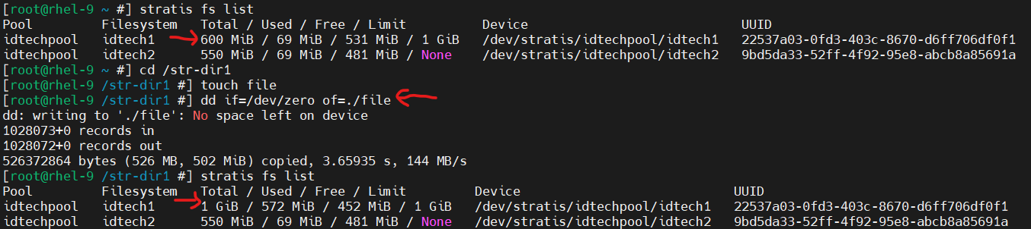
(I have mounted `idtech1` filesystem to `/str-dir1` directory, I will talk about in the next part of the task)

7.Mounting and Checking Filesystems
To mount the filesystems to directories, first I have created directories and then added lines to /etc/fstab.
I have added it to /etc/fstab:
After rebooting, it worked properly.

Task 2

1.Adding New Disk and Create a Partition
To add a new disk, we need to right click to our VM and add Hard Disk from here. Then we can check it inside VM:
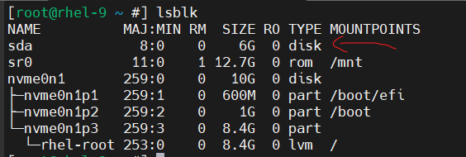
Then we need to create partitions from the disk, and I create one partition from the disk. I have used MBR to divide the disk:
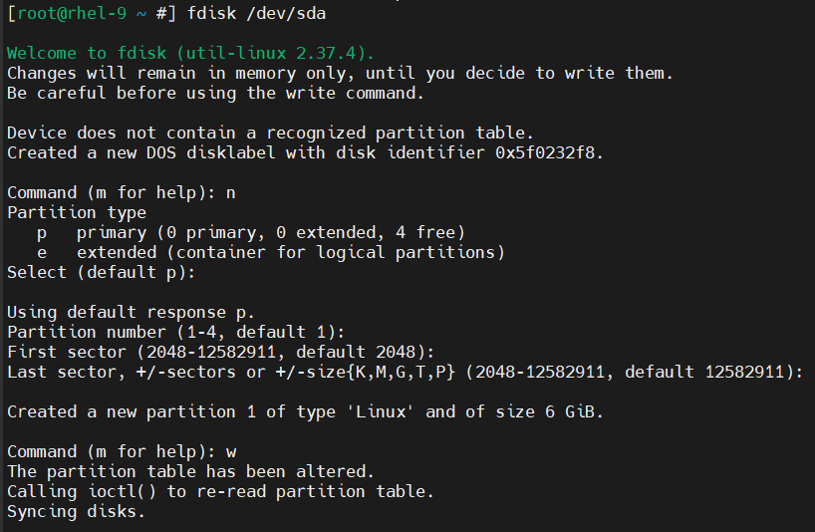
We can see it:
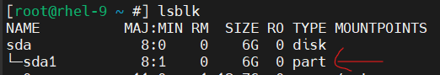

2.Create VG and LV
Then we need to create a VG from that partition:
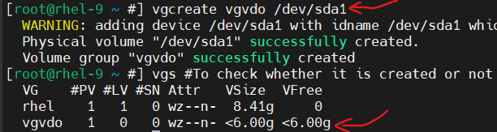

Then we create LV which has VDO:
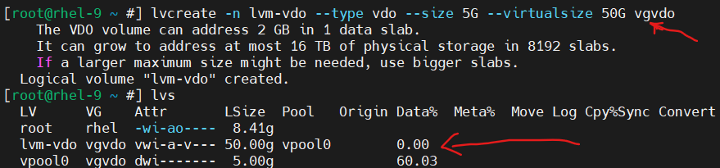

3.Mounting to Fstab
Then we need to mount our LV. To mount permanently we need to add a line to /etc/fstab. First, I take its UUID with `blkid`:
Then create the directory where we want to mount:
Then we add this to fstab file:

To ensure everything works perfectly, we need to reboot the system.
